2026 HUNGER ACTION MONTH
GENERAL INFO, TALKING POINTS, & SOCIAL MEDIA EMPTY PLATE CAMPAIGN TOOLKIT
ABOUT THIS TOOLKIT
Please join us for Hunger Action Month this September by using the below resources to spread awareness and encourage your friends, family, colleagues, and our Valley community to take action to fight food insecurity.
WHAT IS HUNGER ACTION MONTH?
September is Hunger Action Month – an annual nationwide campaign that unites food banks, antihunger organizations, and the public to inspire people to take action against hunger and to raise awareness for those facing food and nutritional insecurity in our communities.
The Feeding America network of food banks launched Hunger Action Month in 2007. In 2026, we mark its 19th year.
Hunger Action Month 2026 comes at a time of rising inflation, growing populations, and compounding global crises. Food insecurity is a chronic emergency affecting millions worldwide. With increasing inflation and population, resources stretched thin, homelessness and poverty on the rise, pandemics and epidemics, and natural disasters, the need for action is now. Hunger Action Month 2026 is needed now more than ever.
CAMPAIGN THEME: Throughout September, the nationwide Feeding America network will mobilize partners, donors, volunteers and advocates around the campaign theme "Play Your Part," highlighting how individual actions, from growing and donating food to packing meals and advocating for policy change, connect into something larger.
HELPFUL LINKS
https://www.feedingamerica.org/take-action/hunger-action-month (Feeding America's dedicated Hunger Action Month page)
https://theopenlink.org/news-events/hunger-action-month-2026.html (our dedicated Hunger Action Month 2026 page)
https://theopenlink.org/get-help/food-nutrition/ (links out to all of our hunger-related programs and resources)
https://theopenlink.org/get-involved/food-drive-tool-kit.html (link to our year-round Food Drive Tool Kit)
IMPORTANT DATES
While Hunger Action Month is throughout the entirety of September, there are also important dates to keep in mind:
Food Bank Day – September 4.
Hunger Action Day – September 29. A day where collective efforts across the country are focused for greater impact. This is the perfect day to share the Plates of Power post.
IMPORTANT TALKING POINTS AND STATISTICS
From The Open Link:
-The food insecurity rate in Montgomery County is 9.9%. That's 85,500 individuals facing food insecurity in our county; 65,026 of them are SNAP recipients. (The missing ~20K are either not enrolled or ineligible due to income limits. It is estimated that 44% of individuals experiencing food insecurity may not be eligible for SNAP.)
-Because of the SNAP cuts and changes in eligibility, SNAP participation has decreased by 11% since July 2025. However, a decline in SNAP participation does not mean decreased food insecurity. There is now more stress on the charitable food system to fill in the gaps once covered by SNAP.
-The Open Link offers a variety of free services that help community members experiencing food insecurity, including our Food Pantry, Food Pantry Without Walls/DoorDash delivery, Summer Kids Meal Program (SKMP), Meals on Wheels, and Benefits Application Assistance (including SNAP application assistance).
-1 in 3 students in the Upper Perkiomen School District rely on the free and reduced school meal program.
-More and more, we are seeing increasing rates of hunger and food insecurity among Valley seniors. Because of SNAP cuts, increased costs of food and transportation, and fixed incomes, seniors are increasingly facing food insecurity.
-At TOL, our Pantry provides two low-income senior communities with grocery delivery twice per month, as well as DoorDash delivery for those who have trouble driving.
-Our case management team helps seniors navigate the increasingly complicated system of acquiring benefits, like SNAP, Medicaid, LIHEAP, rent rebates, and veterans benefits.
-We are also seeing more seniors who are facing complex challenges, such as evictions, memory loss, financial struggles while living low, fixed incomes, and caretaking for spouses.
-Last year, we:
-Served 685 individuals on average per month in our Food Pantr
-Delivered 15,773 meals through Meals on Wheels
-**Summer 2026 – served 23,436 meals through our Summer Kids Meal Program
From Feeding America:
-Great things are never built alone. They require the right pieces coming together with purpose. Ending hunger is an interconnected challenge, and as families face rising food costs, the most important thing we need to put together is us.
-When we connect our actions, we are no longer separate parts. We become an unstoppable movement, building a system that feeds millions of neighbors.
-Your action is the missing piece. Join the movement today and help build a future where no one goes hungry.
TOP 6 WAYS TO TAKE ACTION
If folks ask how they can help (aka “play their part”) during Hunger Action Month, here’s a rundown!
- Donate – Every dollar helps provide groceries or meals to our Valley neighbors facing hunger. Food and supply donations are also welcome! We will provide the Fall 2026 Pantry Needs list once determined.
- Volunteer- Lend your time to volunteer with Meals on Wheels, at The Center, or with one of our other programs.
- Advocate – Use your voice to influence policy and protect vital food assistance programs. Engage with your local, state, and national representatives.
- Partner – Unite your business or organization with us to build a stronger safety net. Become a community sponsor (2027 sponsorship opportunities will become available in September), match employee gifts, donate surplus food or supplies.
- Fundraiser – Rally your friends, family, and network to raise support and end hunger. Host a food drive, cereal club, or other food-related event.
  - The year-round Food Drive Tool Kit is a great resource to share here!
- Spread the word – in our small community, word of mouth plays an enormous role in promoting our organization, connecting potential participants with our programs and services, and increasing public awareness/supporting the well-earned positive reputation of The Open Link. Texts, calls, social media posts (whether sharing your own or sharing them from The Open Link’s pages – see below for sample posts you can share from your accounts), sending out an email – it all helps!
TOL SOCIAL MEDIA ACCOUNTS
*We would love to be tagged in your posts! Here are our names on each platform for easy tagging.
Facebook: The Open Link
Instagram: @theopenlinkpa
LinkedIn: The Open Link
TikTok: The Open Link
HUNGER ACTION MONTH LOGOS
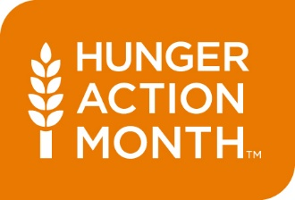
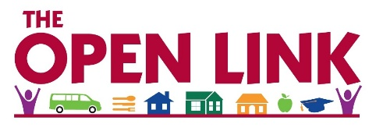

SOCIAL MEDIA COVER PHOTO
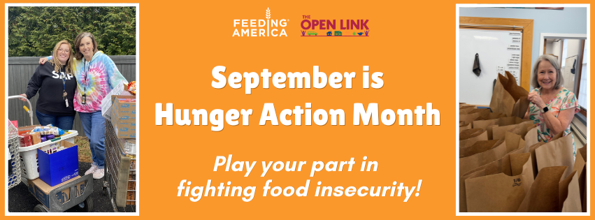

SOCIAL MEDIA HASHTAGS
#TheOpenLink (all month)
#HungerActionMonth (all month)
#HungerActionDay (September 29 only)
SOCIAL MEDIA GRAPHICS AND COPY
FULL PLATES, FULL ____ CAMPAIGN
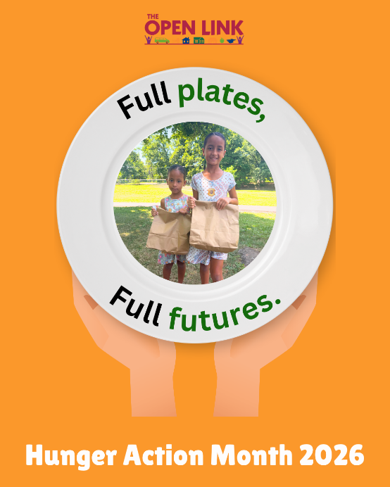
For Full Plates, Full Futures: No kid should ever grow up with an empty stomach. This Hunger Action Month, I’m playing my part by supporting The Open Link to ensure that all Valley kids receive nutritious and accessible food. Learn more at https://theopenlink.org/news-events/hunger-action-month-2026.html #theopenlink #hungeractionmonth
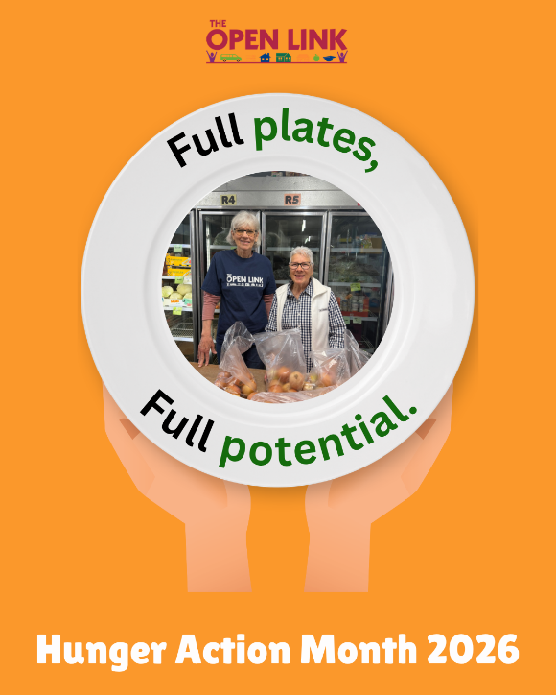
For Full Plates, Full Potential: True community is formed when we make sure no plate is left empty. This Hunger Action Month, play your part and join The Open Link as we work to keep our Valley neighbors’ plates full. Get involved at https://theopenlink.org/news-events/hunger-action-month-2026.html #theopenlink #hungeractionmonth
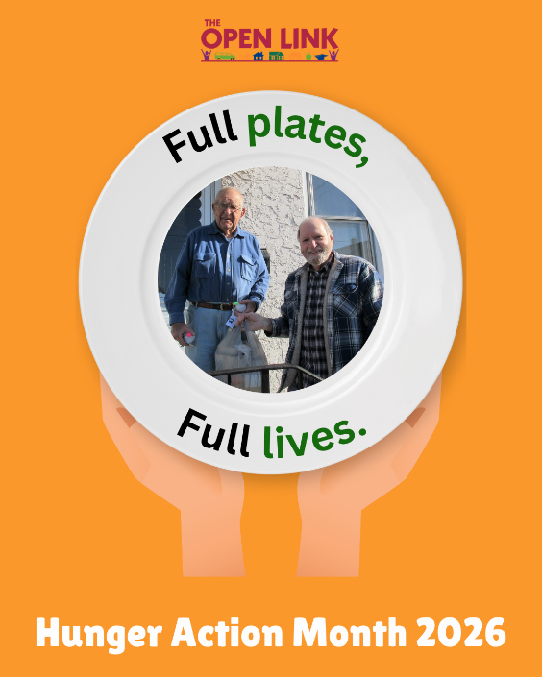
For Full Plates, Full Lives: Meals on Wheels is more than just food. It’s care, connection, and community. This Hunger Action Month, The Open Link needs our support to continue sharing food and friendly faces to our Valley neighbors. Play your part and learn how you can help at https://theopenlink.org/news-events/hunger-action-month-2026.html #theopenlink #hungeractionmonth
FULL PLATE/EMPTY PLATE CAMPAIGN
*You can participate in a few ways:
-Print the image and handwrite your answer. We’d love for you to share a photo of you holding your plate!
-If you are Canva savvy – copy the design into Canva and type in your response!
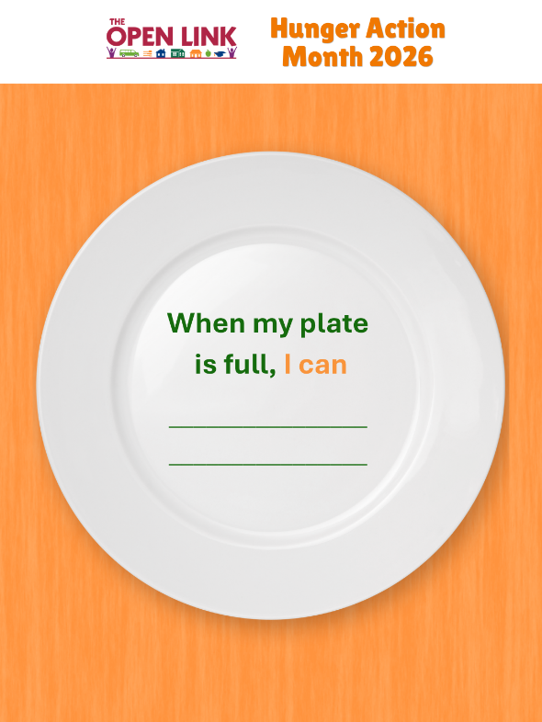
Full Plate: Full plates keep our Valley community healthy, connected, and growing. When my plate is full, I can [insert your personalized message here]. Join me and The Open Link this Hunger Action Month in feeding Valley families and futures. Play your part and learn more at [link] #theopenlink #hungeractionmonth
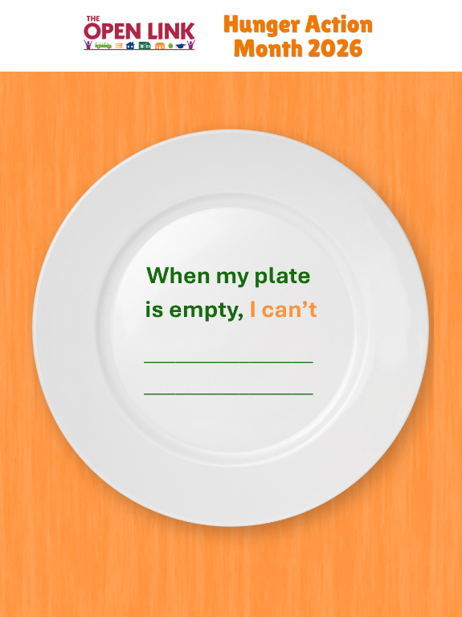
Empty Plate: When my plate is empty, I can’t [insert your personalized message here.] Join me and The Open Link this Hunger Action Month in turning empty plates into full, nourished ones. Play your part and learn more at [link] #theopenlink #hungeractionmonth
**Some ideas here for the blank to get you started:
-Run my business/church/group/etc.
-Be a present parent/grandparent/spouse/family member/boss/volunteer/leader (your choice!)
-Contribute to my community (ex. Be on a board, volunteer)/have the energy to give back to our community
-Think creatively/strategically

PLATES OF POWER CAPTION
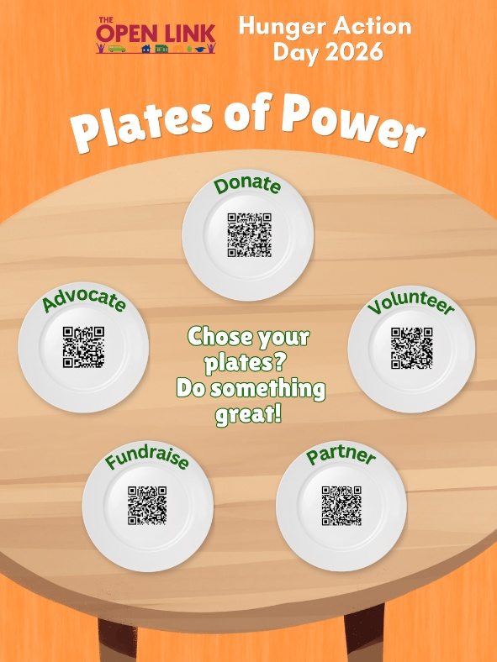
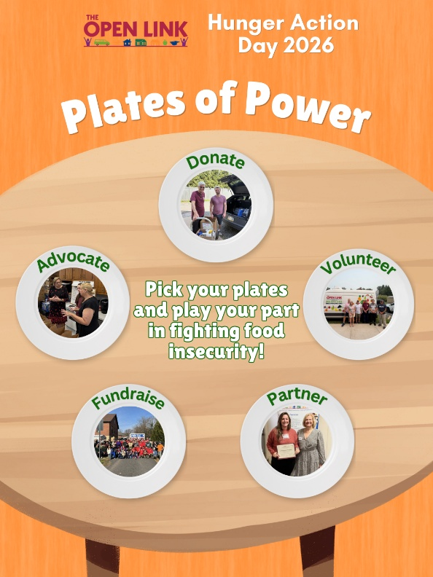
Small, collective actions can lead to big changes in our Valley community. On Hunger Action Day, I’m playing my part, choosing [whatever plates you chose], and [volunteering with, donating to, advocating for, etc.] The Open Link to fight food insecurity in the Valley. Join me in choosing your plates and doing something great. Get involved at [link] #theopenlink #hungeractionday
HAVE QUESTIONS OR NEED HELP?
Contact Alyssa Opdyke, Marketing and Development Manager
Call: 215-679-4112
Email: Alyssao@theopenlink.org
Thanks again for your support during Hunger Action Month!

